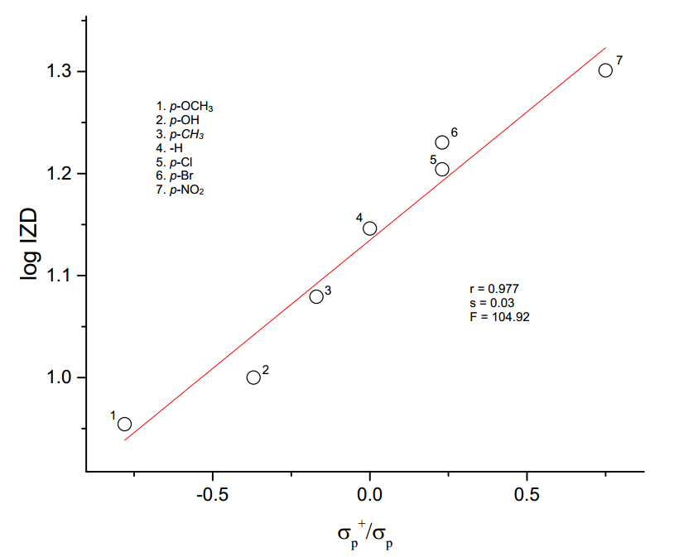

**Fig.4.8 Hammett plot of log IZD vs σp+/ σp**